**LYNCHING DRAMA**

Lynching dramas reflect the brutal history of racial violence in which black individuals, primarily black men, were murdered by a white mob with no repercussions for the murderers. This is the particular form of lynching that became a systematic feature of black/white race relations in the United States after 1865 (when slavery was outlawed in the US Constitution) and that lynching dramas address. References to lynching appear in African American drama as early as 1858 (*The Escape; or a Leap for Freedom* by William Wells Brown), but lynching drama developed as a form when playwrights (both black and white) moved beyond brief references and focused on a specific lynching incident (*Granny Maumee* by Ridgely Torrence, 1914).

Lynching drama was first recognized as a genre of American theatre in the 1998 anthology *Strange Fruit: Plays on Lynching by American Women*, in whicheditors Kathy Perkins and Judith Stephens defined a lynching drama as ‘a play in which the threat or occurrence of a lynching, past or present, has major impact on the dramatic action’ (3). Focusing on the contributions of women playwrights, Perkins and Stephens’s anthology traces the early development of the genre in works like Angelina Weld Grimké’s *Rachel* (1916), Georgia Douglas Johnson’s *A Sunday Morning in the South* (1925) and *Safe* (c. 1929), and Regina M. Anderson Andrews’s *Climbing Jacob’s* Ladder (1931), and documents its continuation in more recent plays like Sandra Seton’s *The Bridge Party* (1989) and Michon Boston’s *Iola’s Letter* (1994). Lynching dramas are a distinct genre of American drama because they are based on lynching as a manifestation of black/white race relations *specifically* in the United States; they reflect the philosophy of both white supremacists who supported lynching (*The Clansman* by Thomas Dixon, 1906) and the historical anti-lynching movement, which originated in the African American community (*Aftermath* by Mary Powell Burrill, 1919). Lynching dramas are written almost exclusively by American playwrights (one known exception is Jean-Paul Sartre’s *The Respectful Prostitute*, 1946) and portray American settings and characters. They have been produced in all regions of the United States and encompass both one-act and full-length plays, as well as a variety of production styles. Because lynching drama developed simultaneously with modern drama, including social realism and folk drama, these plays involve particularized characters speaking and acting in localized settings of daily routine, reflecting the playwrights’ efforts to represent true-to-life individuals instead of type characters..

While each playwright’s treatment of lynching is different, reflecting the time period as well as the artist’s individual perspective and style, the focus on a lynching incident and its impact form the hallmark of the genre. In the first full-length critical study of lynching drama, *Living With Lynching: African American Lynching Plays, Performance, and Citizenship, 1890-1930*, Koritha Mitchell contends that ‘lynching plays served as mechanisms through which African Americans survived the height of mob violence—and its photographic representation—still believing in their right to full citizenship’ (2). Mitchell’s in-depth analysis reveals how ‘[t]his unique genre challenges us to re-evaluate our assumptions about what creates theatrical power and what counts as proof of the impact that a production had on those who experienced it’ (195). Lynching dramas continue to be written and performed in the United States, a recent example being *By Hands Unknown*, created by Kim Gomes and produced at The New School for Drama during the New York City International Fringe Festival in August 2010.

**References and Further Reading**

Perkins, Kathy, and Judith Stephens, eds. (1998) *Strange Fruit: Plays on Lynching by American Women,* Champaign: University of Illinois Press.

Mitchell, Koritha. (2011) *Living With Lynching: African American Lynching Plays, Performance, and Citizenship, 1890-1930,* Champaign: University of Illinois Press.

**Judith Stephens-Lorenz, The Pennsylvania State University**

**Recommended Illustrations**

**[Note: Permissions and proper credits are required for both illustrations. Also, a higher-quality, cropped scan (photo only) of the first illustration of the 1931 production of *Climbing Jacob’s Ladder* is needed. As well, the scan of the flyer in the second image is a bit off-kilter and needs to be straightened up.]**

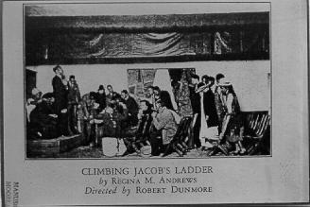

**A scene from the Harlem Experimental Theatre’s 1931 production of *Climbing Jacob’s Ladder* by Regina M. Anderson Andrews (1901-1993). [Source: *The Crisis Magazine*, July 1931]**

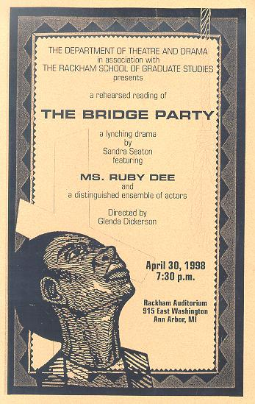

**A flyer from a 1998 staged reading of *The Bridge Party* by Sandra Seaton. The rehearsed reading, presented at the University of Michigan, Ann Arbor, was directed by Professor Glenda Dickerson and featured the actress Ruby Dee. [Source: Department of Theatre and Drama, University of Michigan]**